[Array 17 (2023) 100271](https://doi.org/10.1016/j.array.2022.100271)

|  |  |  |
| --- | --- | --- |
|  |  |  |
|  | Contents lists available at ScienceDirect |  |
| Array |
| journal homepage: [www.sciencedirect.com/journal/array](https://www.sciencedirect.com/journal/array) |

Combating Covid-19 using machine learning and deep learning: Applications, challenges, and future perspectives   
Showmick Guha Paula, Arpa Sahaa, Al Amin Biswasa,*, Md. Sabab Zulfikera, Mohammad Shamsul Arefina,b, Md. Mahfujur Rahmana, Ahmed Wasif Rezac a *Department of Computer Science and Engineering, Daffodil International University, Dhaka, Bangladesh*   
b *Department of Computer Science and Engineering, Chittagong University of Engineering and Technology, Chittagong, Bangladesh* c *Department of Computer Science and Engineering, East West University, Dhaka, Bangladesh*

|  |  |
| --- | --- |
| A R T I C L E I N F O | A B S T R A C T |
| *Keywords:*  Machine learning  Deep learning  Artificial intelligence  Pandemic  COVID-19 | COVID-19, a worldwide pandemic that has affected many people and thousands of individuals have died due to COVID-19, during the last two years. Due to the benefits of Artificial Intelligence (AI) in X-ray image interpre-tation, sound analysis, diagnosis, patient monitoring, and CT image identification, it has been further researched in the area of medical science during the period of COVID-19. This study has assessed the performance and investigated different machine learning (ML), deep learning (DL), and combinations of various ML, DL, and AI approaches that have been employed in recent studies with diverse data formats to combat the problems that have arisen due to the COVID-19 pandemic. Finally, this study shows the comparison among the stand-alone ML and DL-based research works regarding the COVID-19 issues with the combinations of ML, DL, and AI-based research works. After in-depth analysis and comparison, this study responds to the proposed research ques-tions and presents the future research directions in this context. This review work will guide different research groups to develop viable applications based on ML, DL, and AI models, and will also guide healthcare institutes, researchers, and governments by showing them how these techniques can ease the process of tackling the COVID- 19. |

**1. Introduction**

COVID-19, a new coronavirus, emerged in December 2019 as a cluster of deadly serious illnesses in Wuhan, China, and rapidly expanded as an outbreak [1]. The illness is driven by the virus SARS-CoV-2, referred to as COVID-19. WHO labeled COVID-19 a worldwide epidemic on March 11th, 2020 [2]. Therefore, as an outcome of this pandemic, more than six million people have died throughout the world [3]. The COVID-19 pandemic spread worldwide, infecting mil-lions of people. Fig. 1 depicts a worldwide heat map of COVID-19 epidemic deaths.

The most typical signs of the COVID-19 infection include terrible cough, failure of flavor and aroma, migraine, exhaustion, and lung ail-ments such as breathing problems [5,6]. However, medical images such as Chest X-ray (CXR), ultrasonography, computerized tomography (CT), and other imaging techniques have become significant options for diagnosing COVID-19 infection. Because of the extreme contagiousness

of this virus, a rapid and precise diagnosis approach is unquestionably essential for combating this pandemic. Many coronavirus diseases like SARS and MERS can persist in a host species without any symptoms. Contagiousness of this virus, a rapid and precise diagnosis approach is unquestionably essential for combating this pandemic. Sometimes these diseases create extremely weak and non-characteristic signs in the infected individuals. Fig. 2 shows the growth pattern of the COVID-19 spread. It can be found that the growth is exponential. Therefore, it may be possible to predict the upcoming COVID-19 wave and be pre-pared early for it, saving thousands of lives, making prompt detection and treatment of these infections[7].

Since the outbreak of the COVID-19, governments of different countries have implemented strict lockdowns in large cities and urban areas to avoid large gatherings of people and reduce the infection’s impact. COVID-19 has various clinical signs in its early stages, including malaise, migraine, headache, difficulty in breathing, muscle pain, dry mouth, backache, vomiting, and stomach cramps [8,9]. The most

* Corresponding author.

*E-mail addresses:* [showmick.cse@gmail.com](mailto:showmick.cse@gmail.com) (S.G. Paul), [arpasaha.cse@gmail.com](mailto:arpasaha.cse@gmail.com) (A. Saha), [alaminbiswas.cse@gmail.com](mailto:alaminbiswas.cse@gmail.com) (A.A. Biswas), [sabab.rumc@gmail.](mailto:sabab.rumc@gmail.com) [com](mailto:sabab.rumc@gmail.com) (Md.S. Zulfiker)[, sarefin@cuet.ac.bd](mailto:showmick.cse@gmail.com) [(M.S.](mailto:showmick.cse@gmail.com) Arefin), [mrrajuiit@gmail.com](mailto:mrrajuiit@gmail.com) [(Md.M.](mailto:arpasaha.cse@gmail.com) Rahman), [wasif@ewubd.edu](mailto:wasif@ewubd.edu) [(A.W. Reza](mailto:alaminbiswas.cse@gmail.com)).

<https://doi.org/10.1016/j.array.2022.100271>   
[Received 28 October 2022; Received in revis](https://doi.org/10.1016/j.array.2022.100271)ed form 5 December 2022; Accepted 7 December 2022   
Available online 10 December 2022   
[2590-0056](http://creativecommons.org/licenses/by-nc-nd/4.0/)/© 2022 The Authors. Published by Elsevier Inc. This is an open access article under the CC BY-NC-ND license (<http://creativecommons.org/licenses/by-nc-nd/4.0/>).

*S.G. Paul et al.*  *Array 17 (2023) 100271*

prevalent signs for COVID-19 are lack of flavor and aroma [10]. Gov-ernments and regulatory organizations throughout the world have implemented a no-compromise lockdown to preserve social isolation and so limit the epidemic as daily notifications of new breakouts have been flooding in at an unprecedented rate. The most impacted nations have closed their borders to transit and travel to stop the spread of COVID-19. In this global health emergency, the health sector is actively searching for new technology and strategies to monitor and manage the spread of the coronavirus epidemic. AI is currently one of the most effective technology since it can monitor the spread of the Coronavirus, assess its danger and severity, and measure its development rate.

AI is a vast field with several sub-fields that may be used to address difficult issues in our daily lives. Learning, planning, representing in-formation, and seeking are some of these sub-areas. The RT-PCR is currently most widely utilized approaches for COVID-19 detection. Using various data types with different AI-based methods, multiple ap-plications have been developed that can now be used as a replacement for traditional RT-PCR tests. Utilizing different AI-based applications, patient management is becoming more effective, as these applications can efficiently predict patients’ conditions and needs for hospitalization. The identifying and detecting COVID-19 by AI using CXR can early detect the disease and can be automated as a replacement for RT-PCR. AI has been used in forecasting the upcoming waves of the COVID-19 outbreak. By employing different ML, DL, and AI-based models, senti-ment analysis of the public opinions regarding the pandemic has been performed. Also, these models have been used to identify hoax or fake information regarding the COVID-19 pandemic. Which eventually hel-ped to raise public awareness against the pandemic. The ML, DL, and AI- based classification and screening techniques have been used to fine- tune and explore new methods that can more adequately classify and improve the accuracy of detecting the COVID-19 disease. Thus these

techniques can be helpful for COVID-19 management. The widespread use of various techniques of AI for different purposes is driving the way to manage and combat of COVID-19 more efficiently.

Therefore, we have taken the initiative to analyze and explore studies that utilized various techniques in the field of AI to combat COVID-19-related challenges. The following are some of the contribu-tions of our review study:

• Various techniques currently utilized in the field of AI have been explored, and the optimal and most utilized techniques with respect to various data types have been filtered.

• This study outlines future research directions and challenges to the researchers who wants to pursue study in the related field.

• The proposed six state-of-the-art questionnaires that tend to uncover issues, future perspectives, and analysis of the current studies to manage COVID-19 have been addressed.

The organization of the remaining sections is as follows: the review methodology used to conduct the study is discussed in section 2. Section 3 of this study presents the analysis and findings. Section 4 of this study presents finding and analysis of the proposed research questions. Section 5 discusses the challenges and the potential scopes for future research to combat COVID-19. Finally, the study is concluded in section 6.

**2. Review methodology**

As shown by Brereton et al. [11], a review of studies is a technique of discovering, analyzing, and interpreting every accessible material on a particular study topic or topic of attention.

In this study, a comprehensive literature search has been carried out in response to a collection of research queries. Besides, a safe, robust,

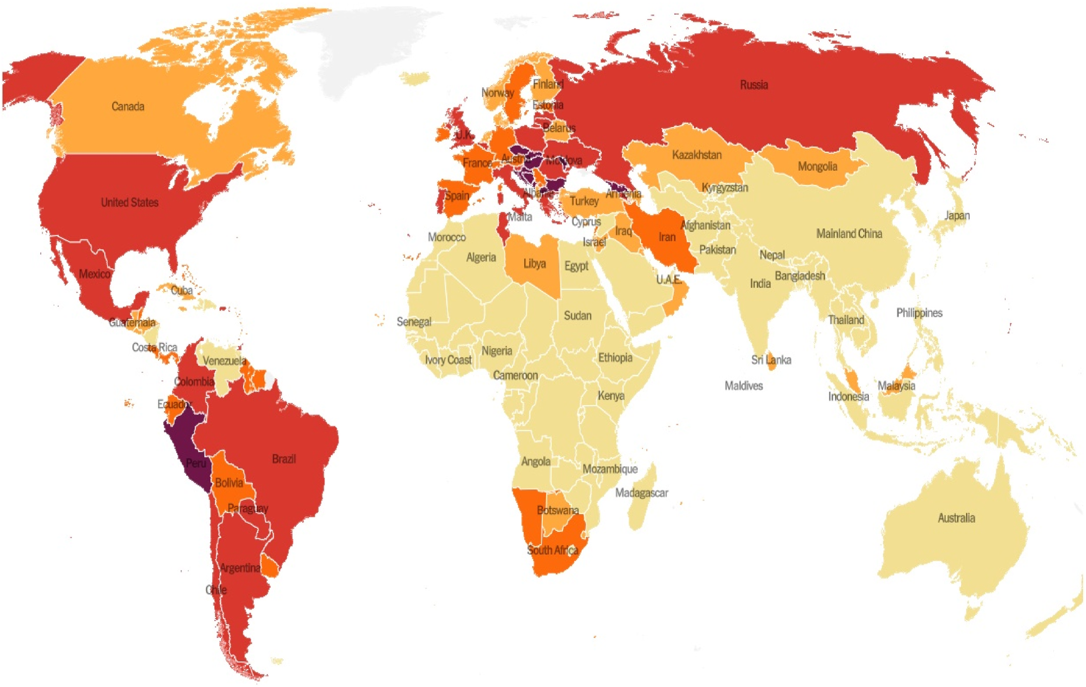

**Fig. 1.** Global heat map of the COVID-19 outbreak death per capita [4].

2

*S.G. Paul et al.*  *Array 17 (2023) 100271*

and quantifiable procedure has been utilized to provide the answer to those concerns.

*2.1. Search strategy*

Multiple online academic search engines such as Scopus, Web of Science, ERIC, PubMed, Science Direct, IEEE Xplore, DOAJ, and Google Scholar were utilized to obtain related studies. Table 1 summarizes the keywords that have been applied to extract the relevant works. Relevant studies were mostly chosen by manually using these keywords in various combinations. Some samples of the combinations are (‘COVID-19′or ’coronavirus’ or ‘CoV2′and ‘machine learning’), (‘coronavirus’ or ‘CoV2′or ‘COVID-19′and ‘deep learning’), (‘COVID-19′or ’coronavirus’ or ‘CoV2′, ‘machine learning’, and ‘prediction’), etc.

*2.2. Inclusion and exclusion criteria*

In this study, only the relevant works published in the English lan-guage have been considered. The inclusion and exclusion criteria for considering the related works are as followings:   
 Inclusion criteria:

(a) Papers that propose at least one ML, DL, or combinations of ML/ DL/AI models.

(b) Studies that discuss at least one of the COVID-19 issues.

(c) Studies performing experimental works on different datasets related to COVID-19.

Exclusion criteria:

(a) Research works published before 2020.

(b) AI, ML, and DL-based techniques mentioned in research articles which are not associated with the COVID-19 epidemic.

(c) COVID-19 issues mentioned in a research work that does not employ ML, DL, or combinations of ML/DL/AI approaches.

(d) Theoretical research with no practical applicability, survey pa- pers, and review papers.

*2.3. Selection of the study*

The process of study selection based on the inclusion and exclusion criteria is presented in Fig. 3   
 In this step, the primary relevant works were selected based on the search strategy discussed earlier. By applying the aforementioned search strategy, 600 studies were identified and selected initially. The duplicate records or studies were then removed in the next phase. After removing the duplicate studies, a total of 512 works remained. 382 studies were

excluded during the screening process. Abstract analysis, dataset anal-ysis, and inclusion and exclusion criteria were used to filter the studies. A total of 130 research works became eligible for full-text analysis through the screening process. Later, these 130 research works were reviewed, and 26 of them were eliminated. In the last stage, a total of 104 studies remained to be checked for their methodological qualities. Among those studies, a total of 16 studies were then excluded based on the methodological quality. After completing all these procedures, only 88 studies remained for the systematic review. Among the selected studies, 29 studies are from the Elsevier journals, 16 studies are from the Springer journals, 11 studies are from the MDPI journals, 10 studies are from various journals referred to as "Others Journal", and 6 studies are from the Nature journals. On the other hand, equal numbers of studies have been collected from the Hindawi and the Wiley journals. From each of these two publishers, 3 studies have been considered. The least number of studies have been collected from the IOP science journals. Only 2 studies have been considered from the journals of this publisher. The remaining 8 studies are conference papers.

*2.4. Extraction of the data*

After selecting the studies, data extraction is very much important to analyze and interpret the studies properly. A general structure is required for the extraction of data from studies to obtain meaningful findings. As a response, tables with some preset attributes were devel-oped, and various data from the studies were added to the tables. The first attribute of the tables, “References and Year,” contains the authors’ name and the publication year. The second attribute defines the pur-poses of the studies. The third and the fourth attributes describe the data types used in the studies and the sample size of the studies, respectively. The fifth attribute specifies the major techniques applied in the studies. Finally, the last attribute mentions the best performing model with its performance.

*2.5. Research questions (RQs)*

This comprehensive and in-depth review mainly focuses on summing up, evaluating, and synthesizing different research works where several ML, DL, and combinations of ML, DL, and AI-based techniques have been considered. The primary goal of this study is to acquire the answers to the subsequent six research questions and to have a profound as well as a comprehensive understanding of the responses to these questions.

**RQ 1**. What ML, DL, and combinations of ML, DL, and AI-based mechanisms are widely used in the studies related to COVID-19?

**RQ 2**. Until now, are there any standard datasets that are publicly available and may be used to analyze different ML, DL, and

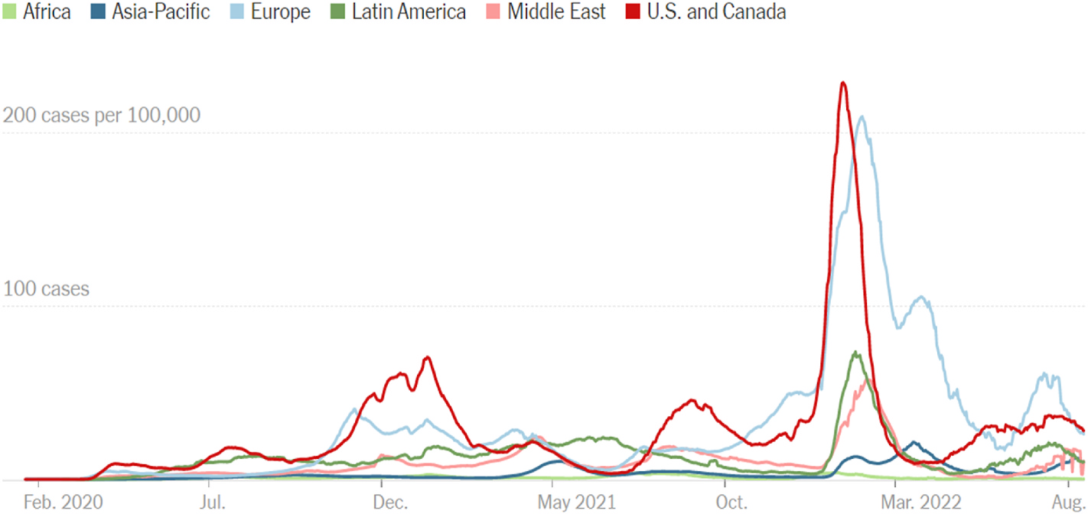

**Fig. 2.** Growth curve for cases by region with cases per capita [4].

3

*S.G. Paul et al.*  *Array 17 (2023) 100271*

combinations of ML, DL, and AI-based techniques?

**RQ 3**. Are there any End-to-End Solutions (E2ES) available for COVID- 19 diagnosis?

**RQ 4**. Which countries performed the most research relating COVID- 19 by involving ML, DL, and combinations of ML, DL, and AI-based techniques?

**RQ 5**. What are the most widely utilized criteria for assessing various works already in existence related to COVID-19 using ML, DL, or com-binations of ML, DL, and AI-based techniques? Are those criteria enough that have been employed in most of these studies?

**RQ 6**. What are the biggest challenges for the researchers who are currently planning to do research on COVID-19 using ML, DL, or com-binations of ML, DL, and AI-based techniques?

**3. Analysis and findings**

Multiple studies have analyzed the application of ML, DL, and AI methods in COVID-19-related studies. Dogan et al. [12] have analyzed

**Table 1**   
Applied keyword

’machine learning’ ’artificial intelligence’, ’deep learning’, ’coronavirus’, ’prediction’, ’classification’, ’detection’,   
’diagnosis’, ’identification’, ’pandemic’, ’sentiment analysis’, ’CoV2’, ’covid-19’, ’ML’,   
’combination’, ’DL’, ’AI’

and reviewed the studies related to the uses of AI and ML mechanisms in the context of various COVID-19-related tasks. In that review study, various studies related to COVID-19 transmission prediction, diagnosis, and detection, and drug/vaccine development have been analyzed, and six predefined questions have been explored. However, the entire context of the COVID-19 pandemic and the application of DL techniques have not been explored in the study.

In another study, Islam et al. [13] reviewed various studies that have employed various AI and ML mechanisms in the process of fighting against the COVID-19 pandemic. Based on the objectives, the studies have been categorized into four groups such as disease detection, epidemic forecasting, sustainable development, and disease diagnosis.

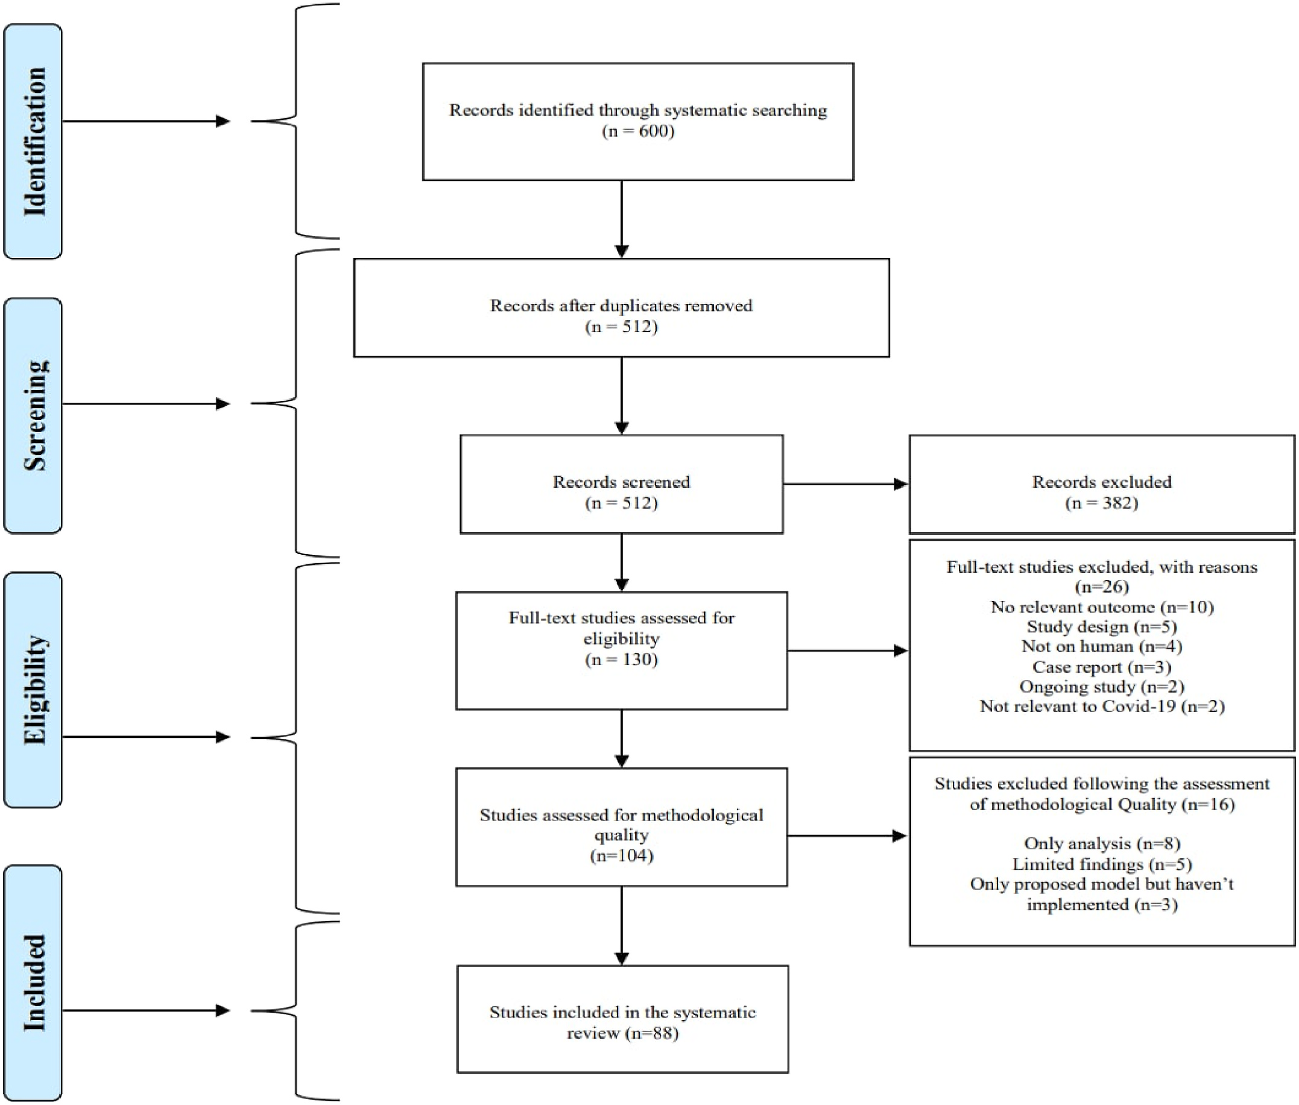

**Fig. 3.** Prisma flow diagram of the selection process of the study based on inclusion and exclusion criteria.

4

*S.G. Paul et al.*  *Array 17 (2023) 100271*

The application of various models has been reviewed and summarized. Furthermore, six research opportunities have been identified and sum-marized in the study. However, other objectives (sentiment analysis, vaccine development, etc.) and the application of DL techniques have not been explored.

A comprehensive review of the role of AI, drones, blockchain, and 5G to manage the COVID-19 pandemic has been performed by Chamola et al. [14]. The study explored the use of current technologies to combat the epidemic as well as its effect on the global economy. The role of Unmanned Aerial Vehicles (UAVs), blockchain, AI, and 5G, among others, in mitigating the effects of the COVID-19 outbreak has been explored and discussed in the studies.

Alballa et al. [15] reviewed recent reports on ML algorithms used in relation to the COVID-19 pandemic. In the study, the applications of ML for diagnosis and predicting patient mortality risk and severity were analyzed. The review includes studies published between January 2020 and January 2021. By assessing the studies, a small number of real-time E2E systems and a selection bias due to imbalanced data were identified. Despite analyzing the ML models for diagnosis and prediction, other COVID-19-related objectives such as detection, epidemic forecasting, etc. have not been considered.

Alafif et al. [16] review the studies conducted on the uses of ML and DL towards COVID-19 diagnosis and treatment. The review study pro-vides a summary of the AI-based ML and DL procedures, the available datasets, performance, and currently available tools. By performing a comprehensive analysis of the current ML and DL approaches used to diagnose COVID-19, obstacles to conducting the studies have been highlighted. In addition, the study made some directions for future work. Although the study analyzed the uses of ML and DL approaches only for the diagnosis and treatment of COVID-19, other perspectives on the probable combination of ML, DL, and the COVID-19 pandemic were not covered.

Although various studies have been conducted to review the works related to the use of ML, DL, and AI-based techniques for COVID-19 management. Very few studies have explored the uses of the possible combination of ML, DL, and AI mechanisms. Moreover, this study explored diverse perspectives on the COVID-19 pandemic, utilizing a variety of data types and combinations of data types. In addition, most recent studies conducted on ML, DL, and the combination of ML, DL, and AI-based mechanisms have been included, as well as some earlier rele-vant studies.

*3.1. Distribution and context of the study*

Among all the considered works, 92% of studies have been collected from different journals, and 8% of studies have been collected from different conferences. From Fig. 4, it can be found that 96% of studies using ML models have been published in different journals, while the rest 4% of studies have been published in different conferences. The percentages of studies employing DL techniques published in journals

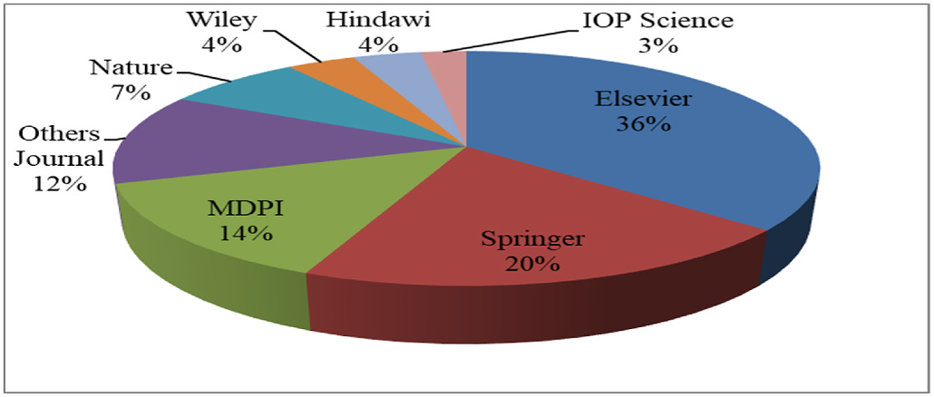

**Fig. 5.** Percentage of the Journal paper collected from different publishers.

and conferences are 80% and 20%, respectively. In terms of applying the combination of ML, DL, and AI-based techniques, 97% of the considered studies are journal papers. The remaining 3% of studies are conference papers.

Among the studies collected from the journals, 36% of the studies are from Elsevier, 20% are from Springer, 14% are from MDPI, 7% are from Nature, 4% are from Hindawi, 4% are from Wiley, 3% are from IOP Science, and 12% are from other journals according to Fig. 5.

The yearly distribution of the studies that were chosen for analysis is shown in Fig. 6. In terms of the publication year, a total of 41 studies were published in 2022. On the other hand, 39 studies were included from 2021. Only 8 studies were included from 2020. In 2022, the studies using the combination of ML, DL, and AI-based models have the highest frequency. The majority of the included studies applying ML techniques were published in 2021. Only a limited numbers of studies employing ML and DL techniques were performed in 2020. Furthermore, no studies applying the combination of ML, DL, and AI-based techniques were included from 2020.

Fig. 7 shows the types of data that were used in various studies. The majority of the studies utilized datasets in image formats. Studies employing datasets in image formats used mainly MRI, CT, CXR, ECG, and X-ray images. The studies that used non-image datasets had mainly worked with different clinical, time-series, textual, and audio data. 54%

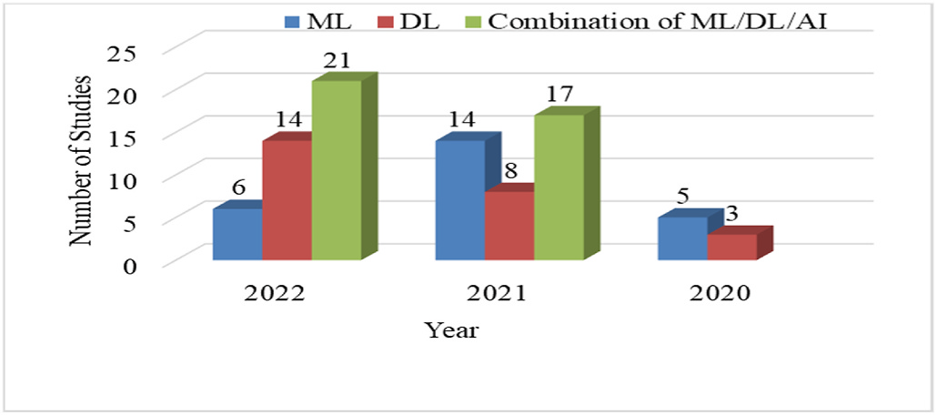

**Fig. 6.** Year-wise distribution of the final selected studies.

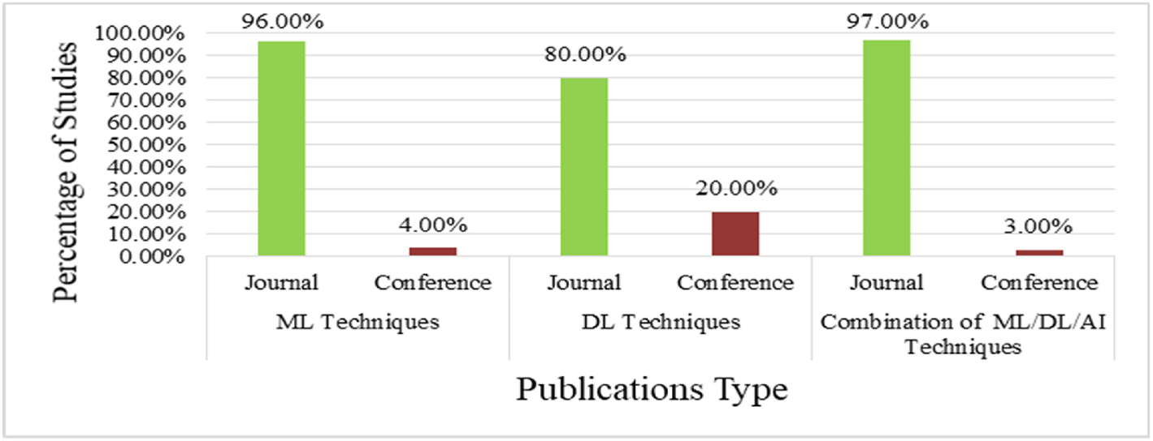

**Fig. 4.** Percentage of studies from different Journal & Conferences.

5

*S.G. Paul et al.*  *Array 17 (2023) 100271*

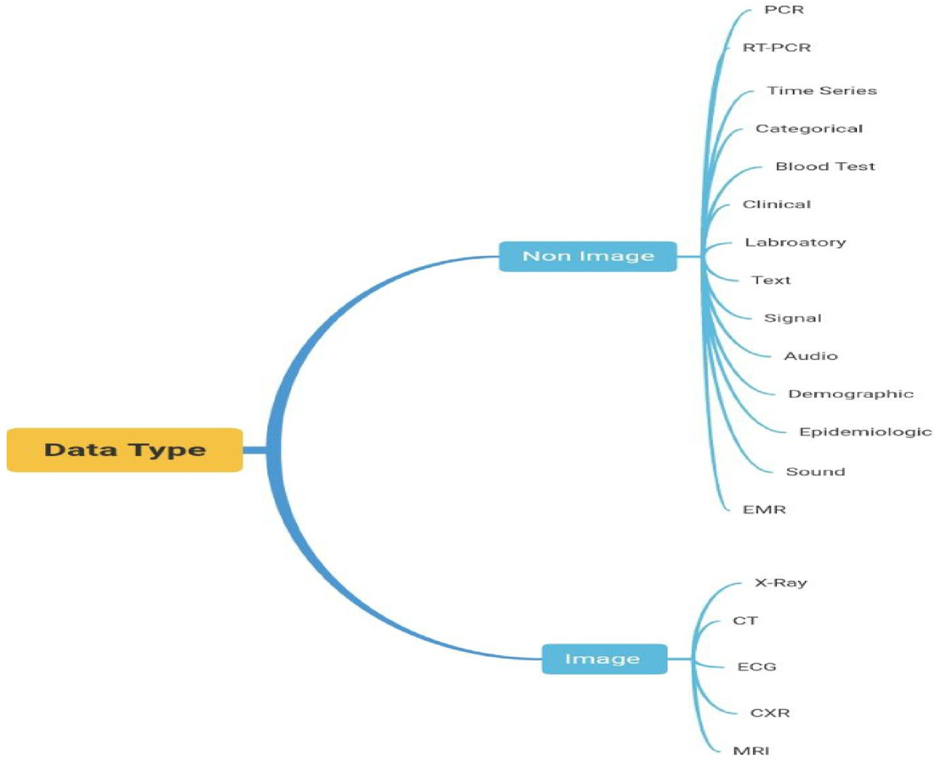

**Fig. 7.** Different types of data used in various studies.

of the total studies employed datasets of image format, the rest 46% studies used non-image datasets.

Among the image data types, CXR has the most significant percent-age, with a percentage of 57%, followed by CT images with a percentage of 28%. X-rays and other images make up the remaining 15% of the data types.

Among the non-image data types, clinical data is the most frequently utilized data format, representing 41% of all the non-image data, fol-lowed by laboratory data, which represents 12% of all the non-image data. 11% data of the non-image data are in time series format. On the other hand, 9% data of the non-image data are in text format. Furthermore, the percentages of audio-sound data, blood test data, and RT-PCR data are 8%, 5%, and 3%, respectively. 11% of the non-image data are of other different data formats.

*3.2. Applications of machine learning to combat COVID-19*

ML is the area of AI that mainly focuses on building systems that are capable of learning without explicit programming to do so. At the beginning of the COVID-19 pandemic, ML algorithms were primarily utilized. Initially, these algorithms were utilized exclusively for geographical and area-wise COVID-19 spread analysis. These algorithms are now being used for various purposes in combating COVID-19. Currently, ML approaches not only can predict COVID-19 by using clinical and laboratory data but also can be used to derive much more complicated aspects of COVID-19. ML approaches show significant performance in the diagnostic process of COVID-19 by utilizing diverse data such as blood images, X-rays, ECG, CT scans, etc. Due to the usage of ML methods for extracting features from images, signals, and audio data, COVID-19’s classification is improving day by day. As ML models achieve more desirable outcomes, they are increasingly being combined with other approaches. The use of several ML methods to address different COVID-19-related problems has been reviewed and presented in this section. Table 2 shows the summary of various studies employing ML models to combat COVID-19.

Fig. 8 shows the frequency of different ML models that have been

6

*S.G. Paul et al.*  *Array 17 (2023) 100271*

**Table 2**

A summary of different machine learning-related studies for COVID-19.

|  |  |  |  |  |  |
| --- | --- | --- | --- | --- | --- |
| References and Year | Purposes | Data Type | Sample Size | Model | Best Model with Performance |
| Abdulkareem et al. [17], (2021)  Callejon-Leblic et al. [18], (2021)  Faisal et al. [19], (2021) | Classification | Laboratory | 600 | RF, BERNOULLI NB, SVM | SVM(Accuracy 95%) |
| Prediction | RT-PCR | 777 | LR, RF, SVM | SVM(Mean Sensitivity of 80.74%) |
| Prediction | Time Series, Categorical | 92,400 | LR, KNN, RBFK-SVM,  PK-SVM, ADB, NB, DT, RF, GB, QDA, ANN  LR, NB, KNN, SVM | DT(Accuracy 90%) |
| Cabitza et al. [20],(2020) | Detection | Blood Test, Clinical | 3 datasets (1624 patients) | CBC dataset(RF Accuracy 93%), COVID-19 dataset (KNN Accuracy 90%), CBC dataset (KNN Accuracy 90%)  XGB(Sensitivity 85%)  RF(Accuracy 88%) |
| Guan et al. [21],(2020) Alves et al. [22],(2021) | Prediction  Classification | Clinical  RT-PCR,  Laboratory Blood test, Clinical  Clinical | 1270  5644 | LASSO R, XGB  LR, RF, XGB, SVM, MLP, ENSEMBLE  RF, SVM, NN, XGB |
| Kukar et al. [23],(2021) | Diagnosis | 5333 | XGB(Sensitivity 81.9%) |
| Muhammad et al. [24], (2020)  Zargari Khuzani et al.  [25],(2021)  Statsenko et al. [26],   (2021)  Tran et al. [27],(2021)  Rezaeijo et al. [28],(2021) | Prediction | 263,007 | DT, LR, NB, SVM, ANN | DT(Accuracy 94.99%) |
| Classification | X-ray | 420 | PCA, NN | NN(Accuracy 94%) |
| Prediction | Clinical | 560 | GB, ADB, ET,RF, NN,LR | NN(with top value AUC 0.86, With all value AUC 0.90) |
| Detection  Classification | Clinical  X-ray | 226  178 | MILO  ADB, BAG, GNB, DT, GBDT, KNN, RF, L-SVM, LR,RFE,MNB RF | MILO(Accuracy of 98.3%)  RFE + KNN(AUC 0.997) |
| Jimenez-Solem et al. [29], (2021)  Hassan et al. [30],(2021) | Prediction | Clinical | 5594 | RF(ROC-AUC of ICU admission 0.802, ventilator treatment 0.815,and death 0.902)  NN(R-Square score Confirmed Cases 0.989086182, Recoveries Cases 0.989356735, Deaths Cases  0.932880987)  LR, and NNs achieved the highest Accuracy (86.42%) |
| Prediction | Time Series | Jan 22- Feb 13 | NN, SVM, BN, PR |
| Saadatmand et al. [31], (2022)  Rehman et al. [32],(2021) Guerrero-Romero et al.  [33],(2022)  Debjit et al. [34],(2022) | Prediction | PCR, Clinical | 398 | LR, RF, XGB, C 5.0, NN |
| Prediction  Identification | X-ray, Clinical Clinical,  Laboratory  Clinical,  Laboratory  Laboratory  Signal | 646  1064 | DT, KNN, NB, ET, RF, SVM LR | RF(Recall 96.00%)  LR(Sensitivity 83%) |
| Prediction | 1,023,426 | HHOXGB, HHOLGB, HHOCAT, HHORF, HHOSVC  NB, SGD, J48, RF, KNN  ENSEMBLE, BT, SVM-LINEAR, LR, LDA, MKNN  TRF, TDT | HHOXGB(Accuracy 92.23%) |
| Almustafa [35],(2021) Erdo˘gan and Narin [36], (2022)  Sciavicco et al. [37],   (2022)  Pourhomayoun and   Shakibi [38],(2020)  Li et al. [39],(2020)  Bayat et al. [40],(2021) | Prediction  Classification | 200,000  1187 records | J48(Accuracy 94.41%)  Ensemble-BT(Recall 90.54%) |
| Classification | Audio | 9986 | TRF(Accuracy 99.4%) |
| Prediction | Clinical | 2,670,000 | SVM, NN, RF, DT, LR,KNN | NN(Accuracy 89.98%) |
| Diagnosis Diagnosis | Clinical  Clinical,  Laboratory Clinical | 413  75,991 | XGB  XGB | XGB(Sensitivity 92.5%)  XGB(Accuracy 86.4%) |
| Hussain et al. [41],(2022) | Prediction | 1085 | SVM, DT, RF, LR | RF(Accuracy 99.24%) |

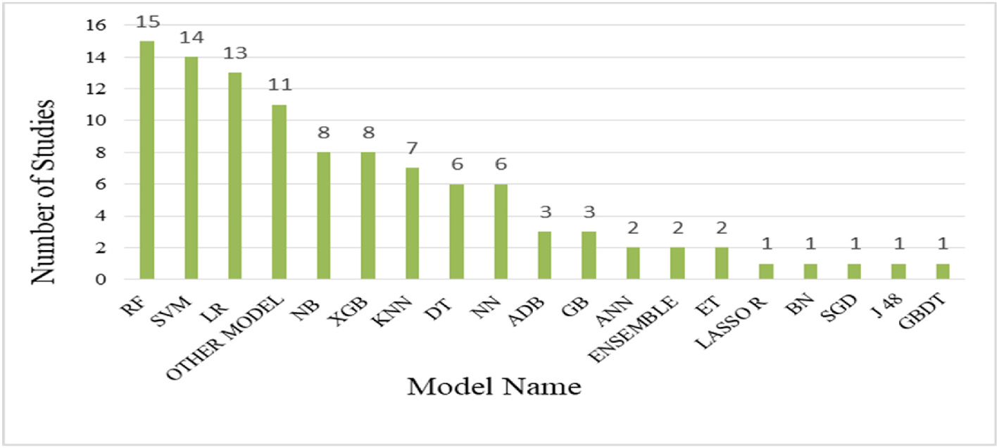

**Fig. 8.** Applied ML models.

and 9 studies, respectively. Other models that consist of various DL models such as (NASNET, COVIDNet, INCEPTIONREST, LSTM, SQUEEZENET, etc.) have achieved the next position with a frequency of 8, followed by MOBILENET(X) with count of 7. Xception, InceptionV3,

7

*S.G. Paul et al.*  *Array 17 (2023) 100271*

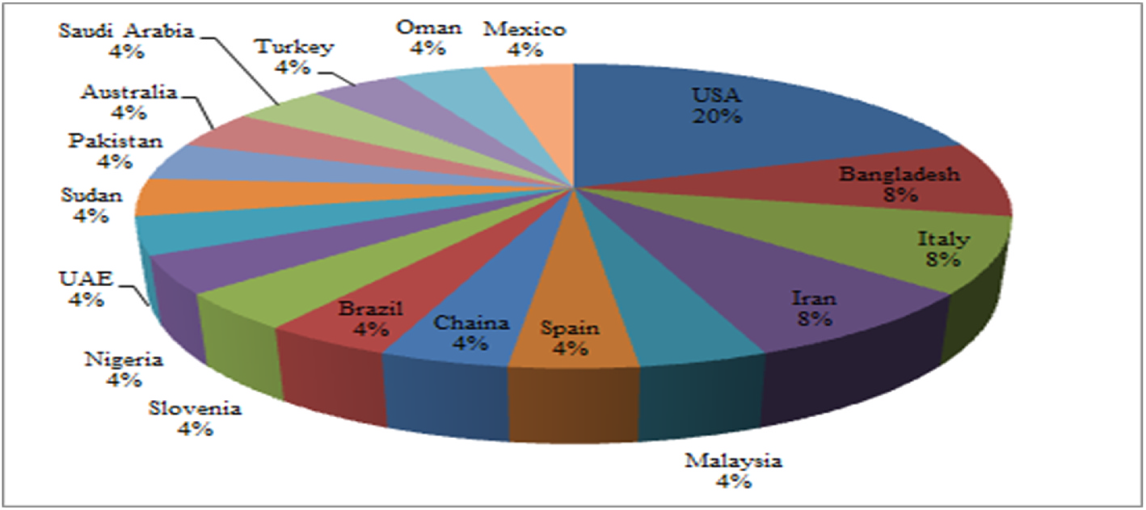

**Fig. 9.** Country-wise percentage of studies using ML Techniques.

From Table 3, it is observed that despite extensive uses of transfer- learning-based models, in the majority of the studies, custom models have outperformed the transfer-learning-based model. From our anal-ysis and observation, for COVID-19 detection-based works with CXR data type, proposed custom CNN models have outperformed the transfer-learning-based CNN models. However, irrespective of the study’s purpose and utilized data type in the uses of transfer-learning- based models, RESNET and DENSENET architecture-based models consisting of various versions have performed best in the majority of the studies. However, regardless of the type of image data used in deep learning-based research work, the usage of custom models may improve performance.

The country-wise percentage of the studies employing DL models is shown in Fig. 11. In terms of using DL models to combat COVID-19, the majority of the research works were performed in India with a per-centage of 44%. 8% of the research works were conducted in each of the following countries: Indonesia and Saudi Arabia. On the other hand, countries such as Algeria, Australia, Turkey, Switzerland, and all other countries have ranked in third place in terms of the number of research works employing DL methods.

*3.4. Application of combination of ML/DL/AI to combat COVID-19*

The combinations of ML, DL, and AI-based techniques are crucial in better understanding and dealing with the COVID-19 situation. The combinations of these methods are rapidly being used since these ap-proaches can open up new avenues for various forms of diagnosis, sentiment analysis, public surveillance, and illness prevention. Several COVID-19 diagnostic approaches based on images aided by DL and AI- based techniques have been developed, and their association with RT- PCR has been evaluated. Image and non-image types of data are inte-grated by the combination of ML, DL, and AI-based methods to inves-tigate several new alternatives to combat COVID-19.

The study demonstrates the combination of ML, DL, and AI meth-odologies and applications for combating COVID-19. Table 4 shows the summary of the combination of ML, DL, and AI-based techniques to combat COVID-19.

Fig. 12 shows that among the ML techniques, SVM has been the most frequently used model in the studies that utilized the combination of ML, DL, and AI-based and it has been used in twenty-three studies. Other ML models like ARIMA, LRG, GB, Total Boost, etc., models have been used in 15 studies. Among the other ML models, RF, DT, KNN, LR, NB, and XGB models have been used in 13, 12, 10, 9, 8 and 7 studies, respectively. The ADB model has been used less frequently among the ML techniques.

Various AI techniques have been used most frequently in the studies. In Fig. 12, for AI technique, we have counted only the numbers of different AI technique instead of showing the number of studies that have employed these techniques. Different DL models such as

8

*S.G. Paul et al.*  *Array 17 (2023) 100271*

**Table 3**

A summary of different deep learning-related studies for COVID-19.

|  |  |  |  |  |  |
| --- | --- | --- | --- | --- | --- |
| References and Year | Purposes | Data Type | Sample Size | Model | Best Model with Performance |
| Ferroukhi [42], (2022)  Sitaula and   Hossain [43], (2020)  Gour and Jain [44], (2021) | Diagnosis | CT | 4708 | VGG16, RESNET 50, MOBILENET,  GOOGLENET, XCEPTION, DENSENET121 VGG16, VGG19, PROPOSED(ATTENTION- BASED VGG-16) | RESNET 50(Accuracy 90%) |
| Classification | CXR | Three datasets of(1125, 1638, 2138 image per dataset)  Three datasets includes (3040,627,2905) CXR | ATTENTION-BASED VGG-16(Accuracy (79.58%, 85.43%, 87.49%)) |
| Classification | CXR | VGG19, RESNET-152, XCEPTION,  DENSENET-169, MOBILENET, NASNET LARGE, INCEPTION-V3, EFFICIENTNET, PROPOSED(UA-CONVNET)  DEEP CNN, FFNN, EFFICIENTNETB7, FUSION MODEL | UA-ConvNet(Sensitivity multiclass = 98.02%, binary = 99.16%) |
| Khan et al. [45], (2022) | Diagnosis | Clinical,  Demographic, CXR  ECG Trace | 270 | Fusion model (Recall 98.6%) |
| Irmak [46],(2022) | Classification | 1937 | CNN, RESNET-101, VGG-19, DENSENET, RESNET-50, VGG-16, INCEPTIONV3  COLI-NET | CNN-proposed model(Accuracy of  98.57%, 93.20%, 96.74%)  COLI-Net(mean Dice coefficients 0.98 and 0.91 l for lung and lesions segmentation) BDCNet(Recall of 98.31%) |
| Shiri et al. [47],   (2021)  Malik et al. [48], (2021)  Kumar et al. [49], (2021) | Detection | CT | 2558 |
| Classification | CT | 660 | RESNET-50, BDCNET, VGG-16, INCEPTION V3,VGG-19,  VGG-16, VGG-19, RESNET18,  ALEXNET, RESNET-50, SARS-NET  CNN, SARS-NET  PROPOSED(CNN-LSTM),  XCEPTION, RESNET50, INCEPTION, VGG 19 VGG16, RESNET50 |
| Detection | CXR | 13,975 | SARS-Net(Sensitivity 92.90%) |
| Mousavi et al.  [50],(2022)  Kavya et al. [51], (2022)  Sundaram et al.  [52],(2021) Luz et al. [53], (2021) | Detection | CXR | 12,931 | CNN-LSTM(Accuracy 90% all scenarios) |
| Detection | CXR | 15,153 | ResNet50(Accuracy 91.39%) |
| Classification | CXR | 4050 | RSQZ-SEGNET | RSqz-SegNet(Accuracy 99.69% binary 99.48% three class)  Approach Flat EfficientNet B3-X(  Sensitivity of 96.8%) |
| Detection | CXR | 13,800 | EFFICIENTNET B0-X, EFFICIENTNET B1-X , EFFICIENTNET B2-X, EFFICIENTNET B3-X , EFFICIENTNET B4-X, EFFICIENTNET B5-X , MOBILENET, MOBILE NET V2, RESNET50, VGG-16, VGG-19  MOBILENET V2 |
| Djuniadi et al.  [54],(2022)  Chaudhary et al.  [55],(2020)  Kogilavani et al.  [56],(2022) Muralidharan et al. [57], (2022) | Detection | Images | 4095 | MobileNet V2(Accuracy 99%) |
| Detection | CXR | 14,000 | EFFICIENTNET-B1, VGG-19, RESNET-50, COVIDNET  VGG16, DESENET121, MOBILENET  , NASNET, XCEPTION, EFFICIENTNET MULTISCALE DCNN | EFFICIENTNet-B1(Accuracy 95%) |
| Detection | CT | 3873 | VGG16(Accuracy 97.68%) |
| Detection | CXR | D1 contains 1225  images, D2 contains 9000 images. | Multiscale DCNN(dataset A(multiclass and binary accuracy of 96% and100%), dataset B(multiclass and binary accuracy of 97.17% and 96.06%))  COVID-CXNet(Accuracy 87.88%) |
| Haghanifar et al.  [58],(2022)  Nassif et al. [59], (2022) | Detection | CXR | 9600 | CHEXNET, COVID-CXNET. |
| Detection | CXR, Audio | 1159 sound samples, 13,808 CXR Image | LSTM, VGG16, VGG19, DENSNET201, RESNET50, INCEPTIONV3,  INCEPTIONRESNETV2, XCEPTION  ALEXNET, VGG16, GOOGLENET, MOBILE NET-V2, SQUEEZENET, RESNET-34,  RESNET-50, INCEPTION-V3  RESNET50 V2, EFFICIENTNET B0 | LSTM (Accuracy of 98%), VGG16  (Accuracy 89.64%), InceptionResNetV2 (Accuracy 82.22%)  ResNet-34(Accuracy 98.33%). |
| Nayak et al. [60], (2020) | Detection | CXR | 406 |
| Verma et al. [61], (2022)  Sim et al. [62],   (2022)  Srivastava and   Ruchilekha   [63],(2022)  Muljo [64],(2022) | Detection | CT | 63,849 | EfficientNet B0(Sensitivity 99.69%) |
| Detection | CXR | 5717 | DENSENET121 | DenseNet121(Sensitivity 95%) |
| Detection | CXR, CT | 4271 | DEEPCOVX, DEEPCOVCT | DeepCovX(Sensitivity 100%), DeepCovCT (Sensitivity 97.06%) |
| Detection | CXR | 133,280 | DENSENET121 | DenseNet121(AUC average of 0.82, best AUC 0.99)  CNN(Accuracy 98%) |
| Panwar et al. [65], (2021)  Nasser et al. [66], (2021) | Classification | CXR | 4563 | CNN, ALEXNET |
| Detection | CXR | 6000 | RESNET50 | ResNet50(Sensitivity 97.3%) |

From Fig. 14 it is obvious that all three approaches use accuracy as the primary evaluation metric. Despite sensitivity/Recall being the second most utilized metric, ML and DL-based studies have used this metric less frequently compared to accuracy. As misclassification of the COVID-19 disease can threaten the patient and their family’s lives in addition to complicating COVID-19’s spread control. Therefore, it is necessary to emphasize the sensitivity/recall metric more for evaluating the model’s performance.

9

*S.G. Paul et al.*  *Array 17 (2023) 100271*

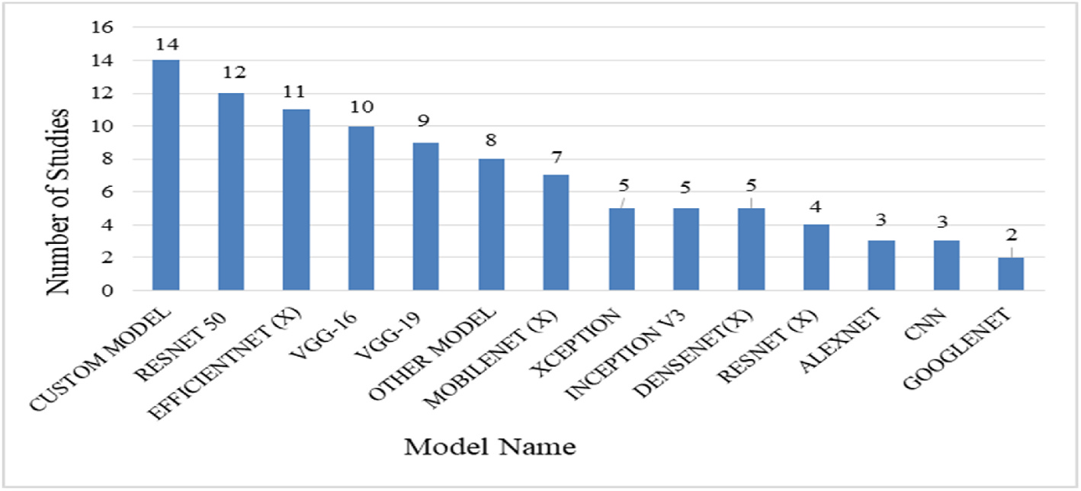

**Fig. 10.** Applied DL models.

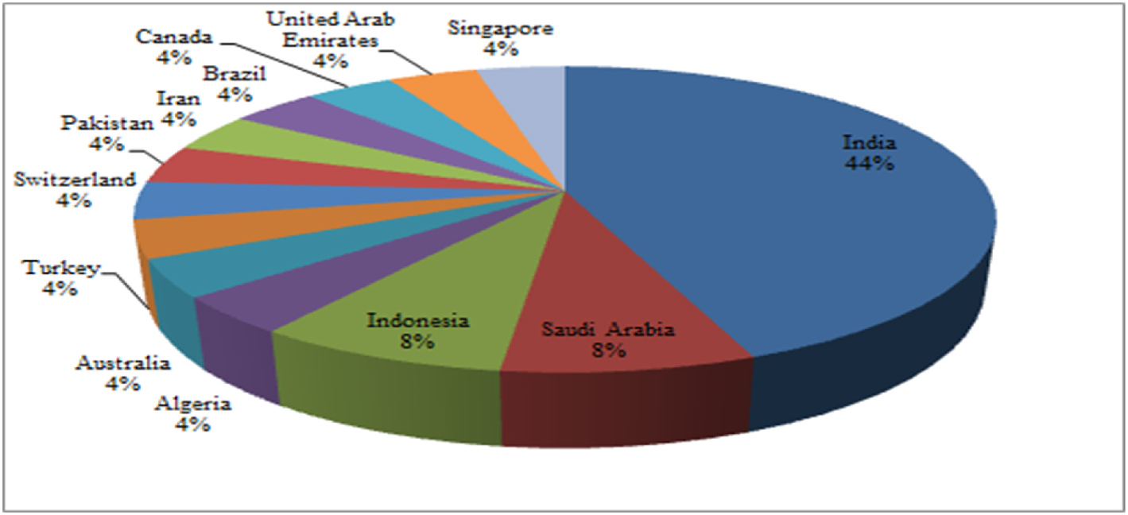

**Fig. 11.** Country-wise percentage of studies using DL models.

RQ 1: In the domain of AI, there are different types of algorithms, each with its own set of advantages and disadvantages. Many factors influence the model’s performance in a positive or negative manner, resulting in less optimum performance and complicating the task of finding ways to combat COVID-19. As a result, it is necessary to identify widely used specific ML, DL, and AI mechanisms so that model selection for a certain purpose becomes simple and effective.

Various models have been applied in the application of the ML model in COVID-19-related tasks. The majority of the studies employed mul-tiple ML models and compared the results. Therefore, the finding of some top-utilized models can be very beneficial. RF, SVM, LR, NB, XGB, and KNN are some of the most frequently used models. In addition to the use of specific ML models, various diversified but not widely used models have also been applied.

Analyzing the studies, it can be observed that XGB has performed as the best model among utilized ML mechanisms, followed by RF and NN. Therefore, while using the ML model for prediction, classification, detection, and diagnosis, XGB, RF, and NN models can be considered, which may aid in achieving the best possible result.

Many studies have developed custom models and compared them to other existing mechanisms in the use of DL relevant to the COVID-19 study. In the use of specific DL models, RESTNET50, EFFICIENTNET, VGG-16, VGG-19, and MOBIELNET have been the most widely applied models. Analyzing the studies, it can be shown that custom models performed the best among the used DL mechanisms, followed by ResNet- (X) referring to various versions of ResNet particularly ResNet-50.

In the application of the combination of ML, DL, and AI techniques related to the COVID-19 study, many studies applied the combination of diverse mechanisms and analyzed the performance, limitations, and

10

*S.G. Paul et al.*  *Array 17 (2023) 100271*

**Table 4**

A summary of different combination of ML/DL/AI related studies for COVID-19.

|  |  |  |  |  |  |
| --- | --- | --- | --- | --- | --- |
| References and Year | Purposes | Data Type | Sample Size | Model | Best Model with Performance |
| Tariq et al. [67], (2021)  Wang et al. [68], (2021) | Prediction | EMR, Clinical | 3194 | FM, LR, LASSO R, XGB, RF, CNN | FM(F1-score 84%) |
| Classification | CT | 1418 | V-NET, 3D U-NET++, DPN-92, RESNET-50, RESNET, FCN–8S, U-NET, INCEPTION NET-  WORKS, ATTENTION RESNET-50  ADB, RF, XGB, DNN | ResNet-50 with 3D U-Net++ (Sensitivity 97.4%) |
| Chung et al. [69], (2021)  Afshar et al. [70], (2022)  Sheela and Arun   [71], (2022)  Babaei Rikan [72], (2021) | Prediction | Clinical | 5601 | DNN(Sensitivity 90.2%) |
| Diagnosis | CT, Clinical | 160 | MLP, DNN | Two-stage time-distributed capsule network(Sensitivity of 94.3%)  Hybrid PSO-SVM (Sensitivity 95.6%) |
| Identification | MRI | 200 | HYBRID PSO-SVM, SVM, PSO, DBN, SAE |
| Diagnosis | Laboratory, Blood Tests | D1 279,D2 1624, D3 600 | SVM, NB, ET, RF,LR, KNN, DT, XGB, DNN, CNN, LSTM, RNN | DNN(D1 (accuracy 92.11%), D2  (Accuracy 93.16%), D3 (Accuracy 93.16%)  Darknet53 + NCA + SVM(Accuracy 99.05 and 97.1%) |
| Yildirim et al. [73], (2022) | Classification | CXR | 15,470 | ALEXNET, RESNET50, GOOGLENET,  DENSENET201, DARKNET53,  MOBILENETV2, EFCIENTNETB0,  INCEPTIONV3, NCA, DT, DA, NB, SVM, KNN, SE  BN, NB, RBF, SVM, AB, OR, DEREX |
| De Falco et al. [74], (2021)  Lella and Pja [75], (2021)  Hipolito Canario   et al. [76],(2022) | Classification | CXR | 13,808 | RBF(Average Accuracy 79.60%), DEREx(Best Accuracy 80.67%) DCNN(Accuracy 95.45%) |
| Diagnosis | Sound,Clinical | 18,000 | DAE, GFCC, IMFCC,DCNN, VGG NET, SVM |
| Identification | CXR | 722 | M-QXR | M-qXR(Identify pulmonary opacities Sensitivity 94%), detecting pulmonary opacities Sensitivity 94%), Identify pulmonary consolidation Sensitivity 91%), PPV 89.7%, and NPV 80.4% Proposed(Recall 98.58%) |
| Kini et al. [77], (2022) | Screening | CT | 12,146 | JLM, AGGDF, WSDL, DECNN, DLCRD, PARL, GCNN, GOOGLENET, IPCNN, RESNET152V2, DENSENET201, IRNV2, ENSEMBLE DL  (PROPOSED)  LR, KNN, SVM, VGG19 |
| Messaoud et al.  [78],(2022)  Liang et al. [79], (2022) | Detection | Clinical, X-ray, CT  CT | 270 patient,2251 and 746 image  1,552,988 | VGG19(Accuracy 90%) |
| Diagnosis | RESNET-18, RESNEXT50, GRU, DCNN, SVM, LK, PK, RBF KERNEL, DEEPLABV3,  DENSENET121, GPR, FL FRAMEWORK  COVID-NET, MULTI-MODAL | Boosting (AUC 0.98), DL + FL(Dice’s coefficient of 0.77) |
| Tan et al. [80], (2022) | Classification | CXR, CT | Covid-19 1394,  Pneumonia 11,712, Negative 20,431  1486 | Multi-modal(AUC 0.93) |
| Chen et al. [81],   (2022)  Alkhaldi et al. [82], (2022)  Mahbub et al. [83], (2022) | Diagnosis | Sounds | KNN, CNN, MFCCS | CNN(Accuracy 97%) |
| Sentiment Analysis  Screening | Text | 2750 | TF-IDF, CRNN, RNN, RF, XGB, SVM, ET, DT, SFO, SFODLD-SAC  RESNET50, RESNET152V2, PROPOSED DNN (COVTBPNNET), INCEPTIONNETV3,  MOBILENETV2 | SFODLD-SAC(Accuracy 99.65%) |
| CXR | C1: COVID-191,200, C2: Pneumonia 3,875, C3:Tuberculoss 3,500, C4: Healthy 6182 | CovTbPnNet Accuracy (healthy CXR Screening(99.87% on COVID-19,  99.55% on Pneumonia versus, for TB versus 99.76%), non–healthy CXR  Screening(98.89% on COVID-19 versus Pneumonia, 98.99% on COVID-19  versus TB, and Pneumonia versus TB 100%))  The Deep LSTM network(beds,  respiratory equipment, and cases  number yielded MAPE values of  (2.89%, 3.29%, and 4.80%) and R  Squared values (99.90%, 99.85%, and 99.72%), respectively)  Proposed Method (78.6% Dice Score, 71.1% Sensitivity, 99.3% Specificity, 85.6% Precision, 0.062 Mean Average Error metric) |
| Koç and Türko˘glu [84],(2021) | Forecasting | Time Series | 77-day | DEEP LSTM NETWORK, ADAM, LSTM, ARIMA, SVM, DT, LR |
| Elharrouss et al. [85],(2021) | Segmentation | CT | 100 | U-NET,ATTENTION-UNET, GATED-UNET, DENSE-UNET, U-NET++, SEMI–INF–NET, MULTI-CLASS U-NET, DEEPLABV3+, FC8S, PROPOSED METHOD (MULTI-TASK DL  METHOD)  PROPOSED MODEL (BAYESIAN-BASED  OPTIMIZED DEEP LEARNING MODEL)  LSTM, BI-LSTM, CONVLSTM, COBID-NET ENSEMBLE  FINE-TUNING BERT, LRG, TF-IDF, KNN, SVM, DPCNN, EXPERT SYSTEM  LR, RF, XGB, SGAN |
| Loey et al. [86],   (2022)  Shastri et al. [87], (2021)  Zhang et al. [88], (2022)  Tavakolian et al.  [89],(2022)  Choudrie et al. [90], (2021) | Detection | CXR | 10,848 | Proposed Model(Accuracy 96%) |
| Forecasting | Time Series | 421-days | CoBiD-Net ensemble model(Accuracy 98.10–99.13%)  Fine-tuning BERT(Recall 99%) |
| Classification | Time Series, Text | 11,303,850 |
| Screening | Clinical | 5,435,996 | SGAN (Accuracy 99.2%, 99.6% for COVID-19 and H1N1)  DT (Accuracy 86.7%, Sensitivity 88.89%) |
| Classification | Text | 143 | SVM, DT, RF, SGD, LSTM, CNN |
| Diagnosis | 4600 |

(*continued on next page*)

11

*S.G. Paul et al.*  *Array 17 (2023) 100271*

**Table 4** (*continued*)

|  |  |  |  |  |  |
| --- | --- | --- | --- | --- | --- |
| References and Year | Purposes | Data Type | Sample Size | Model | Best Model with Performance |
| Saha et al. [91],   (2021)  Zulfiker et al. [92], (2022)  Shiri et al. [93],   (2021)  Aslan et al. [94],   (2022) | Sentiment  Analysis  Classification | CXR  Text | 1075 | EMCNET, CNN, RF, SVM, DT, ADB,  ENSEMBLING  LSTM, 1D-CNN, BI-LSTM, TCN, DT, GB, SVM, LDA  CNN, LR, LASSO, LDA, RF, ADB, NB, MLP, ANOVA, KW, RFE, RELIEF  ALEXNET, INCEPTIONV3, RESNET18, SVM, RESNET50, ANN, DT, NB, DENSENET201, INCEPTIONRESNETV2, MOBILENETV2,  GOOGLENET, KNN  DT, KNN, SVM, NB, RF, CNN, SE,RESNET50, INCEPTIONV3,EDLN,  PROPOSED(MULTI-COVID-NET)  DNN, CNN, 2DCNN, BI-LSTM, SVM LINEAR, SVM RBF,  SVM POLYNOMIAL, LR, COVID-OPT-AINET | EMCNet(Accuracy 98.91%, Precision 100%)  Bi-LSTM with word2vec embedding (Sensitivity 88.52%)  ANOVA feature selector, and RF  classifier(Sensitivity 81%)  DenseNet201 and SVM(Sensitivity 96.42%) |
| CT | 14,339 |
| Classification | CXR | 2905 |
| Goel et al. [95], (2021) | CXR | 2700 | 2700 | Multi-COVID-Net(Sensitivity 99.63%) |
| Kanwal et al. [96], (2021) | Detection | CXR | 18,394 | COVID-opt-aiNet(Accuracy of SVM 98%–99%, Accuracy of CNN  70.85%–71% ,Accuracy of DNN 96%– 97% )  VGG-19 with BRISK(Accuracy 96.6%) |
| Bhattacharyya et al. [97],(2021) | Detection | CXR | 247 | C-GAN, VGG-19, SCNN, DENSENET-169, VGG-16, DENSENET-201, SOFTMAX, SVM, RF, XGB, SIFT, BRISK  RF, GA, DNN, SHAP |
| Davazdahemami   et al. [98],(2022) Karim et al. [99],   (2022)  Khan et al. [100], (2021)  Dhruv et al. [101], (2022) | Prediction | Clinical, Time Series  CXR | 27,215 | GA with DNN(AUC 0.883) |
| Detection | 27,605 | CNN, NB, SVM, SOFTMAX, KNN, DT | NB + Ant Lion Optimization + CNN (98.31% Accuracy, 100% Precision)  DNN(Sensitivity 97%) |
| Prediction | Epidemiological | 2,676,311 | DT, LR, RF, XGB, KNN, DNN |
| Diagnosis | CT | 17,104 | INRFNET AND INNET, DENSENET-121,  RESIDUAL  ATTENTION, ENSEMBLE WITH FC,  ENSEMBLE WITH FC + SVM  SVM-LINEAR, SVM-POLYNOMIAL, SVM-RBF, VGG-16, INCEPTIONV3, XCEPTION,  RESNET50, CCGAN,  GNB, SVM, DT, LR, RF, CNN, ENSEMBLE | InRFNet Sensitivity(94.48%) |
| Janbi and Elnazer [102], (2021) | Diagnosis | CXR | 6308 | RESNET50(Recall 99.49%) |
| Islam and   Nahiduzzaman   [103], (2022)  Alabrah et al. [104], (2022) | Detection | X-ray | 2482 | Ensemble(Recall 99.73%) |
| Sentiment Analysis | Text | 464 records | LSTM, SVM, FINE-KNN, ENSEMBLE, BOOST, TOTAL BOOST | Fine-KNN and Ensemble boost (Accuracy 94.01%) |

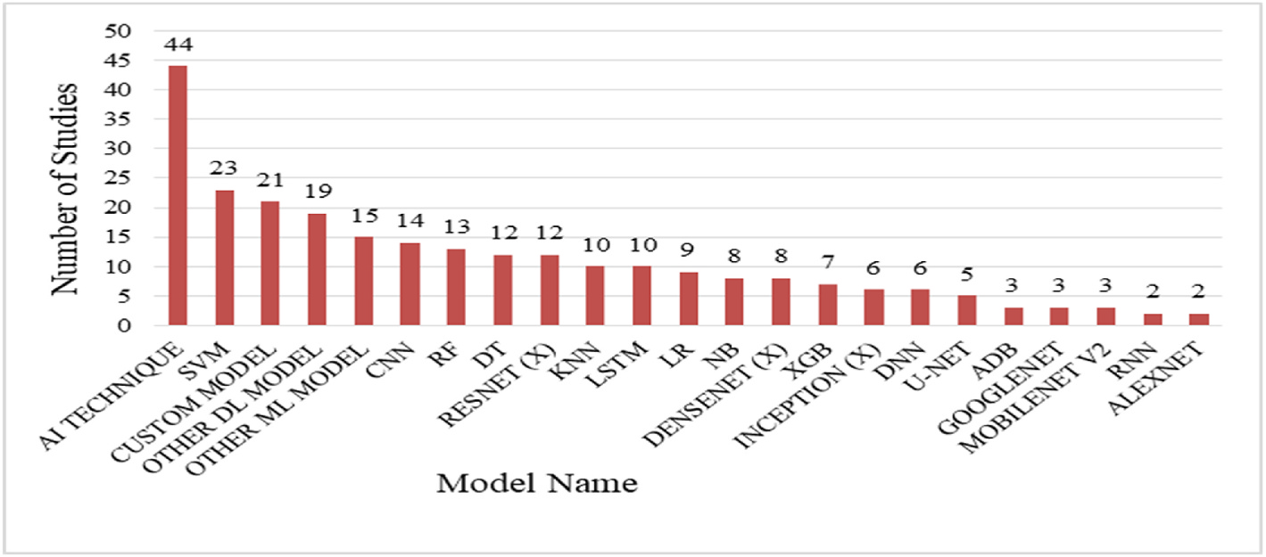

**Fig. 12.** Applied combination of ML/DL/AI models.

this reason, sometimes there could be some lagging in the data collection procedure, which can create imbalanced and nonstandard data. There-fore, creating a standard dataset is important. Comparing the study re-sults with the standard dataset is also important.

As COVID-19 is a global pandemic, many governments and NGOs have released open-access COVID-19 datasets, which mostly involve vaccination-related and spread-related datasets. But to identify the COVID-19 virus in the human body, an image type dataset is needed. Due to various constraints, there is a shortage of publicly available image datasets at the beginning of the period. Now there are some in-dividual studies that have given open access to their dataset. But most of the individual datasets have some limitations, such as being imbalanced,

12

*S.G. Paul et al.*  *Array 17 (2023) 100271*

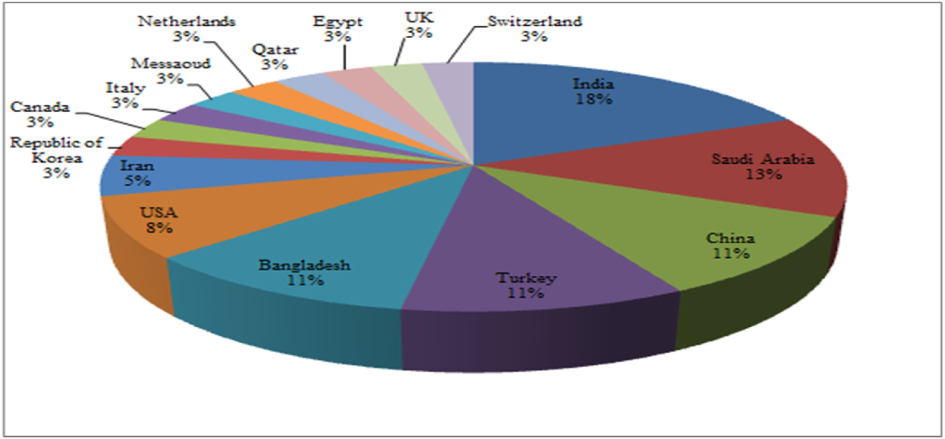

**Fig. 13.** Country-wise percentage of studies using combination of ML/DL/AI models.

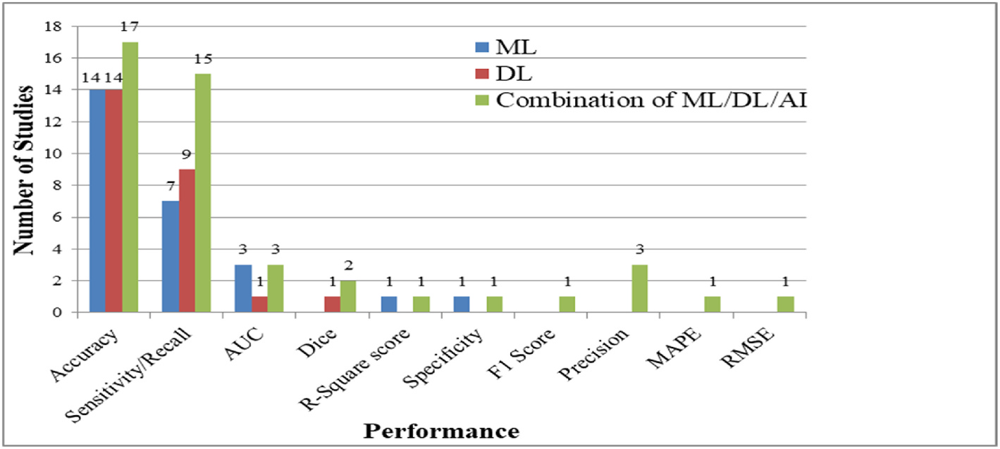

**Fig. 14.** Performance evaluation metrics used in various studies.

RQ 3: RT-PCR is the traditional method used to detect COVID-19 disease in the human body. Patients must physically visit a hospital to give samples for testing the suspected COVID-19 present in their bodies while using the traditional testing method. However, between the waves of the COVID-19 pandemic, visiting the hospital is a risky step. Because visiting the hospital in the middle of the COVID-19 wave can affect healthy people, who can further act as hosts and further spread the disease. Therefore, it is important to find some End-to-End solution based on AI, which can remotely and effectively diagnose COVID-19 in a suspected person.

But most of the studies have not emphasized building an End to End solution for diagnosis. Despite that, many studies have been conducted in order to develop an application for an End-to-End diagnosis solution [61,81]. Most studies consider image data types such as X-ray, CT, MRI, etc. to build COVID-19 diagnosis E2ES. As a result, using those appli-cations, the patient’s standard form of X-ray, CT, and MRI data sample is needed, which must be primarily obtained from the clinic or hospital. Therefore, the E2ES hardly solves the problem of remote E2ES systems. Some studies have considered using sound and audio data to build E2ES for the COVID-19 diagnosis system, which can diagnose COVID-19 remotely. However, low sound-quality recording devices and environ-mental noise can downgrade the quality of captured audio and sound data, which may affect the performance of the application. Furthermore, these studies and applications have some certain circumscribed. Therefore, there is still a lack of standard and reliable E2ES for the diagnosis of COVID-19.

As there is a lack of E2E systems regarding various COVID-19-related work. The researchers should more focus on the issue and develop more E2E systems. Furthermore, the researcher should concentrate on

13

*S.G. Paul et al.*  *Array 17 (2023) 100271*

RQ 5: For combating the COVID-19 pandemic, many studies have been conducted for various purposes and using various mechanisms. Various domains of AI have been used with diverse modifications and combinations. Furthermore, various types of data and a mixture of data types have been used to perform studies. Therefore, there is a need to evaluate the studies with a standard form of evaluationmetrics. Addi-tionally, there is a need to identify the criteria that have been used in those studies to evaluate the trustworthiness of the studies. Most of the studies have used some of the evaluation metrics such as accuracy, sensitivity/recall, precision, F1 score, AUC-ROC curve, etc. From analyzing the studies’ utilized metrics, the accuracy metric has been used in most of the studies, followed by sensitivity and recall. Other evaluation metrics have been used less frequently in the related studies. However, the researchers should focus on the True Positive Rate instead of accuracy.

As COVID-19 is a pandemic and can transmit from person to person very rapidly, the top priority is to stop the spread. Therefore, it is crucial not to misidentify an infected person rather than misidentify a healthy person. Therefore, the researchers should prioritize the True Positive Rate or recall value rather than accuracy, as recall value focuses on capturing all true positives, even if it increases false positive rate.

RQ 6: Due to the COVID-19 pandemic, there have been instanced number of research works conducted to manage and to combat the pandemic by the use of ML, DL, and combinations of ML, DL, and AI- based techniques. Those research works have been analyzed and iden-tified various factors and purposes associated with COVID-19 using ML, DL, and combinations of ML, DL, and AI-based techniques. However, from those studies, some common challenges and limitations can be outlined. Identifying those challenges can be beneficial for the re-searchers who are planning to do research by applying the ML, DL, and AI methods as they can study those challenges to overcome in their study or can make their study particularly based on finding the solution to those challenges.

Selection of an effective model from the variety of models available from various domains of ML, DL, and AI is a challenging and time- consuming task. Some traditional ML, DL, and AI methods have already been extensively researched. However, there is still scope for improvements, but it will be challenging. Additionally, finding an effective combination of ML, DL, and AI is a challenging task that re-quires a significant amount of time and expertise. The scarcity of stan-dards and enough sample data is one of the fundamental challenges when it comes to working with COVID-19. These are the two most fundamental challenges for researchers who intend to conduct research using ML, DL, or combinations of ML, DL, and AI-based techniques.

**5. Challenges and future research opportunities**

Many ML, DL, and other AI approaches depend on massive training data, such as clinical data, medical images, and other types of medical data. Large-scale training data is scarce and unavailable. It should be noted that determining the best models for COVID-19 diagnosis is challenging because of the scarcity of data. Further research is required to solve this issue. Moreover, a benchmark dataset is required for diagnosing COVID-19.

Since the COVID-19 virus’s arrival, various variants have appeared due to mutations. Gathering data for different variants in a short period is complex, and there is always a shortage of COVID-19-related updated datasets. A combined and effective data gathering strategy is required to address this issue. Furthermore, a change in the variant might alter the performance of a model, which has been trained by a different variant previously. Hence, more research works are needed to investigate the performance of the previous studies on the new variants of COVID-19.

COVID-19 samples have a low count of CT, MRI, and X-ray images compared to pneumonia infection and healthy human case samples. Data argumentation tries to generate new image sample from the existing samples by flipping, rotating, zooming, adding random noise in

14

*S.G. Paul et al.*  *Array 17 (2023) 100271*

of 88 studies has been made. Among these studies, 25 studies employed ML techniques, 25 studies employed DL techniques, and the rest 38 studies utilized the combination of ML, DL, and AI-based methods. This study has analyzed the prior research works by summarizing the applied methods in those works, comparing the performance of different models used and identifying the purpose of those works.

92% of these studies are from different journals, and the rest 8% of these studies are conference papers. Most of the studies analyzed in this work are from 2022. USA conducted the maximum number of research works employing ML methods. On the other hand, the maximum num-ber of works utilizing DL methods and the combination of ML, DL, and AI-based methods have been performed in India. RF model has been used most frequently in studies employing ML models, whereas different custom models have the highest frequency in DL-based studies. A variety of AI-based techniques have the highest frequency in the studies utiliz-ing the combination of ML, Dl, and AI-based methods. In the evaluation process, most studies have emphasized accuracy to evaluate the per-formance of the proposed models.

The significant information discovered, investigated, and reported in this study are contemporary and up-to-date regarding COVID-19. For the appropriate content, we utilized precise keywords. These search terms yielded valuable results to achieve the aim of this study, though there is a chance we may have missed significant resources that are not shown by these terms. Some data might have been missed during the extraction of data from the selected studies.

Various ML, DL, and combinations of ML, DL, and AI-based methods have emerged in recent years. In future, more combinations of different methods and complicated approaches can be analyzed for fighting against COVID-19. Future research works can consider combining a variety of data formats to precisely identify COVID-19.

**Declaration of competing interest**

The authors declare that they have no known competing financial interests or personal relationships that could have appeared to influence the work reported in this paper.

**Data availability**

No data was used for the research described in the article.

**Nomenclature**

SVM Support Vector Machine   
BERNOULLI INB Bernoulli Naive Bayes   
RF Random Forest   
LR Logistic Regression   
KNN   
 K-Nearest Neighbor DT Decision Tree   
RBFK-SVM Radial Basis Function SVM   
RNN Recurrent Neural Network   
ANN Artificial Neural Network   
ADB Adaboost   
NB Naive Bayes   
GB Gradient Boosting   
QDA Qualitative Data Analysis   
RFE Recursive Feature Elimination   
LASSO R Lasso Regression   
XGB Xgboost   
MLP Multilayer Perceptron   
NCA   
 Necessary Condition Analysis DEREx Differential-Evolution-based Rule Extractor DAE De-noising Auto Encoder   
LASSO Least Absolute Shrinkage and Selection Operator ConvLSTM Convolutional Long Short Term Memory IMFCC Improved Multi-frequency Cepstral Coefficients

15

*S.G. Paul et al.*  *Array 17 (2023) 100271*

PARL Prior-attention Residual Learning   
AGGDF Adaptive Feature Selection Guided Deep Forest   
GCNN Genetic CNN   
GRU Gated Recurrent Unit   
TF-IDF Term Frequency–Inverse Document Frequency   
SCNN Self-Customized Simple CNN   
SIFT Scale-Invariant Feature Transform   
BRISK Binary Robust Invariant Scalable Key-Points   
CCGA Continuous Conditional Generative Adversarial Network DLCRD Deep Learning-based Chest Radiograph Diagnosis   
ADAM Adaptive Moment Estimation   
PK-SVM Polynomial Kernel Support Vector Machines   
BAG   
 Bagging MERS Middle East Respiratory Syndrome   
AI Artificial Intelligence   
CXR Chest X-ray   
MRI   
 Magnetic Resonance Imaging SARS Severe Acute Respiratory Syndrome   
CT Computerized Tomography   
RT-PCR Reverse Transcription-Polymerase Chain Reaction ECG Electrocardiogram   
ML Machine Learning   
SARS-CoV-2 Severe Acute Respiratory Syndrome Coronavirus 2 DL Deep Learning   
WHO The World Health Organization   
NLP   
 Natural Language Processing MAPE Mean Absolute Percentage Error   
DOAJ Directory of Open Access Journals   
RMSE Root Mean Square Error

**References**

[1] Wu Y-C, et al. The outbreak of COVID-19: an overview. J Chin Med Assoc Mar. 2020;83(3):217–20. <https://doi.org/10.1097/JCMA.0000000000000270>.

[2] WHO Director-Gener[al’s opening remarks at the media briefing on COVI](https://doi.org/10.1097/JCMA.0000000000000270)D-19 - 11 March 2020. Available: [https://www.who.int/director-general/speeches/detail](https://www.who.int/director-general/speeches/detail/who-director-general-s-opening-remarks-at-the-media-briefing-on-covid-19---11-march-2020) [/who-director-general-s-opening-remarks-at-the-media-briefing-on-covid-19—](https://www.who.int/director-general/speeches/detail/who-director-general-s-opening-remarks-at-the-media-briefing-on-covid-19---11-march-2020) [11-march-2020](https://www.who.int/director-general/speeches/detail/who-director-general-s-opening-remarks-at-the-media-briefing-on-covid-19---11-march-2020) [[Accessed 26 June 2022].](https://www.who.int/director-general/speeches/detail/who-director-general-s-opening-remarks-at-the-media-briefing-on-covid-19---11-march-2020)

[3] [Worldometer: C](https://www.who.int/director-general/speeches/detail/who-director-general-s-opening-remarks-at-the-media-briefing-on-covid-19---11-march-2020)OVID-19 Coronavirus Pandemic. Available: [https://www.wor](https://www.worldometers.info/coronavirus/) [ldometers.info/coronavirus/](https://www.worldometers.info/coronavirus/) [Accessed 26 June 2022].

[4] [Coronavirus World Map: Tra](https://www.worldometers.info/coronavirus/)cking the Global Outbreak. Available:[https://www.](https://www.nytimes.com/interactive/2021/world/covid-cases.html)

[nytimes.com/interactive/2021/world/covid-cases.html](https://www.nytimes.com/interactive/2021/world/covid-cases.html) [Accessed [26 June 2022].](https://www.nytimes.com/interactive/2021/world/covid-cases.html)

[5] Jalaber C, et al. Chest CT in COVID-19 pneumonia: a review of current knowledge. Diagnostic and Interventional Imaging 2020;101(7–8):431–7.

<https://doi.org/10.1016/j.diii.2020.06.001>.

[6] [Ibrahim NK. Epidemiologic surveillance for](https://doi.org/10.1016/j.diii.2020.06.001) controlling Covid-19 pandemic: types, challenges and implications. Journal of Infection and Public Health 2020; 13(11):1630–1638, Nov. <https://doi.org/10.1016/j.jiph.2020.07.019>.

[7] Oran DP, Topol EJ. Preva[lence of asymptomatic SARS-CoV-2 infectio](https://doi.org/10.1016/j.jiph.2020.07.019)n: a narrative review. Ann Intern Med 2020;173(5):362–7. [https://doi.org/10.7326/](https://doi.org/10.7326/M20-3012) [M20-3012](https://doi.org/10.7326/M20-3012).

[8] [Wu Z, Mc](https://doi.org/10.7326/M20-3012)Googan JM. Characteristics of and important lessons from the coronavirus disease 2019 (COVID-19) outbreak in China: summary of a report of 72 314 cases from the Chinese center for disease control and prevention. JAMA 2020;323(13). <https://doi.org/10.1001/jama.2020.2648>.

[9] Pang KW, et al. [Frequency and clinical utility of olfactor](https://doi.org/10.1001/jama.2020.2648)y dysfunction in COVID- 19: a systematic review and meta-analysis. Curr Allergy Asthma Rep 2020;20 (12):76. <https://doi.org/10.1007/s11882-020-00972-y>.

[10] Rocke J, [et al. Is loss of sense of smell a diagnostic ma](https://doi.org/10.1007/s11882-020-00972-y)rker in COVID-19: a systematic review and meta-analysis. Clin Otolaryngol Nov. 2020;45(6):914–22. <https://doi.org/10.1111/coa.13620>.

[11] [Brereton P, et al. Lessons from appl](https://doi.org/10.1111/coa.13620)ying the systematic literature review process within the software engineering domain. J Syst Software 2007;80(4):571–83. <https://doi.org/10.1016/j.jss.2006.07.009>.

[12] [Dogan O, Tiwari S, Jabbar MA, Guggari S](https://doi.org/10.1016/j.jss.2006.07.009). A systematic review on AI/ML approaches against COVID-19 outbreak. Complex Intell. Syst. 2021;7(5): 2655–78. <https://doi.org/10.1007/s40747-021-00424-8>.

[13] Islam MN, [Inan TT, Rafi S, Akter SS, Sarker IH, Islam A](https://doi.org/10.1007/s40747-021-00424-8)KMN. A systematic review on the use of AI and ML for fighting the COVID-19 pandemic. IEEE Trans. Artif. Intell. Dec. 2020;1(3):258–70. <https://doi.org/10.1109/TAI.2021.3062771>.

[14] Chamola V, Hassija V, Gupta V[, Guizani M. A comprehensive review of th](https://doi.org/10.1109/TAI.2021.3062771)e COVID-19 pandemic and the role of IoT, drones, AI, blockchain, and 5G in managing its impact. IEEE Access 2020;8:90225–65. [https://doi.org/10.1109/](https://doi.org/10.1109/ACCESS.2020.2992341) [ACCESS.2020.2992341](https://doi.org/10.1109/ACCESS.2020.2992341).

16

*S.G. Paul et al.*  *Array 17 (2023) 100271*

[43] Sitaula C, Hossain MB. Attention-based VGG-16 model for COVID-19 chest X-ray image classification. Appl Intell May 2021;51(5):2850–63. [https://doi.org/](https://doi.org/10.1007/s10489-020-02055-x) [10.1007/s10489-020-02055-x](https://doi.org/10.1007/s10489-020-02055-x).

[44] [Gour M, Jain S. Uncertainty-a](https://doi.org/10.1007/s10489-020-02055-x)ware convolutional neural network for COVID-19 X- ray images classification. Comput Biol Med 2022;140:105047. [https://doi.org/](https://doi.org/10.1016/j.compbiomed.2021.105047) [10.1016/j.compbiomed.2021.105047](https://doi.org/10.1016/j.compbiomed.2021.105047).

[45] [Khan IU, et al. Using a deep learning](https://doi.org/10.1016/j.compbiomed.2021.105047) model to explore the impact of clinical data on COVID-19 diagnosis using chest X-ray. Sensors Jan. 2022;22(2):669. [https://](https://doi.org/10.3390/s22020669) [doi.org/10.3390/s22020669](https://doi.org/10.3390/s22020669).

[46] [Irmak E. COVID-19 disease](https://doi.org/10.3390/s22020669) diagnosis from paper-based ECG trace image data using a novel convolutional neural network model. Phys Eng Sci Med Mar. 2022; 45(1):167–79. <https://doi.org/10.1007/s13246-022-01102-w>.

[47] Shiri I, et al. C[OLI-Net : deep learning-assisted fully automat](https://doi.org/10.1007/s13246-022-01102-w)ed COVID -19 lung and infection pneumonia lesion detection and segmentation from chest computed tomography images. Int J Imag Syst Technol Jan. 2022;32(1):12–25. [https://doi.](https://doi.org/10.1002/ima.22672) [org/10.1002/ima.22672](https://doi.org/10.1002/ima.22672).

[48] [Malik H, et al. BDCNet:](https://doi.org/10.1002/ima.22672) multi-classification convolutional neural network model for classification of COVID-19, pneumonia, and lung cancer from chest   
radiographs. Multimed Syst Jun. 2022;28(3):815–29. [https://doi.org/10.1007/](https://doi.org/10.1007/s00530-021-00878-3) [s00530-021-00878-3](https://doi.org/10.1007/s00530-021-00878-3).

[49] [A. Kumar at al. “SAR](https://doi.org/10.1007/s00530-021-00878-3)S-Net. COVID-19 detection from chest x-rays by combining graph convolutional network and convolutional neural network. Pattern Recogn 2022;122:108255. <https://doi.org/10.1016/j.patcog.2021.108255>.

[50] Mousavi Z, et al. C[OVID-19 detection using chest X-ray images ba](https://doi.org/10.1016/j.patcog.2021.108255)sed on a developed deep neural network. SLAS Technology Feb. 2022;27(1):63–75.

<https://doi.org/10.1016/j.slast.2021.10.011>.

[51] [Sri Kavya N, et al. Detecting Covid19 and p](https://doi.org/10.1016/j.slast.2021.10.011)neumonia from chest X-ray images using deep convolutional neural networks. Mater Today Proc 2022;64:737–43. <https://doi.org/10.1016/j.matpr.2022.05.199>.

[52] [Sundaram SG, et al. Deep transfer learning bas](https://doi.org/10.1016/j.matpr.2022.05.199)ed unified framework for COVID19 classification and infection detection from chest X-ray images. Arabian J Sci Eng 2022;47(2):1675–1692, Feb. <https://doi.org/10.1007/s13369-021-05958-0>.

[53] Luz E, et al. Towards an effect[ive and efficient deep learning model for COV](https://doi.org/10.1007/s13369-021-05958-0)ID-19 patterns detection in X-ray images. Res. Biomed. Eng. Mar. 2022;38(1):149–62. <https://doi.org/10.1007/s42600-021-00151-6>.

[54] [Djuniadi, et al. Face mask detection services o](https://doi.org/10.1007/s42600-021-00151-6)f Covid19 monitoring system to maintain a safe environment using deep learning method. IOP Conf Ser Earth Environ Sci 2022;969(1). <https://doi.org/10.1088/1755-1315/969/1/012016>. 012016.

[55] Chaudhary Y, et al. Efficient-CovidNet: deep learning based COVID-19 detection from chest X-ray images. In: 2020 IEEE international conference on E-health networking, application & services (HEALTHCOM). Shenzhen, China: Mar.; 2021. p. 1–6. <https://doi.org/10.1109/HEALTHCOM49281.2021.9398980>.

[56] Kogilav[ani SV, et al. COVID-19 detection based on lung ct scan usin](https://doi.org/10.1109/HEALTHCOM49281.2021.9398980)g deep learning techniques. Comput Math Methods Med 2022:1–13. [https://doi.org/](https://doi.org/10.1155/2022/7672196) [10.1155/2022/7672196](https://doi.org/10.1155/2022/7672196).

[57] [Muralidharan N, et al. D](https://doi.org/10.1155/2022/7672196)etection of COVID19 from X-ray images using multiscale deep convolutional neural network. Appl Soft Comput 2022;119:108610. [https://](https://doi.org/10.1016/j.asoc.2022.108610) [doi.org/10.1016/j.asoc.2022.108610](https://doi.org/10.1016/j.asoc.2022.108610).

[58] [Haghanifar A, et al. COVID-CXNet: d](https://doi.org/10.1016/j.asoc.2022.108610)etecting COVID-19 in frontal chest X-ray images using deep learning. Multimed Tools Appl; 2022. [https://doi.org/](https://doi.org/10.1007/s11042-022-12156-z) [10.1007/s11042-022-12156-z](https://doi.org/10.1007/s11042-022-12156-z).

[59] [Nassif AB, et al. COVID-19 de](https://doi.org/10.1007/s11042-022-12156-z)tection systems using deep-learning algorithms based on speech and image data. Mathematics 2022;10(4):564. [https://doi.org/](https://doi.org/10.3390/math10040564) [10.3390/math10040564](https://doi.org/10.3390/math10040564).

[60] [Nayak SR, et al. Applicat](https://doi.org/10.3390/math10040564)ion of deep learning techniques for detection of COVID- 19 cases using chest X-ray images: a comprehensive study. Biomed Signal Process Control 2021;64:102365. <https://doi.org/10.1016/j.bspc.2020.102365>.

[61] Verma A, et al. Detecting [COVID-19 from chest computed tomography](https://doi.org/10.1016/j.bspc.2020.102365) scans using AI-driven android application. Comput Biol Med 2022;143:105298.

<https://doi.org/10.1016/j.compbiomed.2022.105298>.

[62] [Sim JZT, et al. Diagnostic performance of a deep lear](https://doi.org/10.1016/j.compbiomed.2022.105298)ning model deployed at a national COVID-19 screening facility for detection of pneumonia on frontal chest radiographs. Healthcare Jan. 2022;10(1):175. [https://doi.org/10.3390/](https://doi.org/10.3390/healthcare10010175) [healthcare10010175](https://doi.org/10.3390/healthcare10010175).

[63] [Srivastava V, Ruchil](https://doi.org/10.3390/healthcare10010175)ekha. Diagnosing covid-19 using AI based medical image analysis. In: 5th joint international conference on data science & management of data (9th ACM IKDD CODS and 27th COMAD); Jan. 2022. p. 204–12. [https://doi.](https://doi.org/10.1145/3493700.3493730) [org/10.1145/3493700.3493730](https://doi.org/10.1145/3493700.3493730). Bangalore India.

[64] [Improving lung disease detectio](https://doi.org/10.1145/3493700.3493730)n by joint learning with COVID-19 radiography database. Commun. Math. Biol. Neurosci. 2022. [https://doi.org/10.28919/](https://doi.org/10.28919/cmbn/6838) [cmbn/6838](https://doi.org/10.28919/cmbn/6838).

[65] [Panwar A,](https://doi.org/10.28919/cmbn/6838) et al. COVID 19, pneumonia and other disease classification using chest X-ray images. In: 2021 2nd international conference for emerging technology (INCET); May 2021. p. 1–4. [https://doi.org/10.1109/](https://doi.org/10.1109/INCET51464.2021.9456192)   
[INCET51464.2021.9456192](https://doi.org/10.1109/INCET51464.2021.9456192). Belagavi, I[ndia.](https://doi.org/10.1109/INCET51464.2021.9456192)

[66] [Nasser N, et al. A deep learn](https://doi.org/10.1109/INCET51464.2021.9456192)ing-based system for detecting COVID-19 patients. In: ICC 2021 - IEEE international conference on communications. Montreal, QC: Canada; Jun. 2021. p. 1–6. <https://doi.org/10.1109/ICC42927.2021.9500460>. [67] Taeiq A, et al. Patient-speci[fic COVID-19 resource utilization prediction usin](https://doi.org/10.1109/ICC42927.2021.9500460)g fusion AI model. npj Digit. Med. 2021;4(1):94. [https://doi.org/10.1038/s41746-](https://doi.org/10.1038/s41746-021-00461-0) [021-00461-0](https://doi.org/10.1038/s41746-021-00461-0).

[68] [Wang B, et a](https://doi.org/10.1038/s41746-021-00461-0)l. AI-assisted CT imaging analysis for COVID-19 screening: building and deploying a medical AI system. Appl Soft Comput 2021;98:106897. [https://](https://doi.org/10.1016/j.asoc.2020.106897) [doi.org/10.1016/j.asoc.2020.106897](https://doi.org/10.1016/j.asoc.2020.106897).

17

*S.G. Paul et al.*  *Array 17 (2023) 100271*

[95] Goel T, et al. Multi-COVID-Net: multi-objective optimized network for COVID-19 diagnosis from chest X-ray images. Appl Soft Comput 2022;115:108250. [https://](https://doi.org/10.1016/j.asoc.2021.108250) [doi.org/10.1016/j.asoc.2021.108250](https://doi.org/10.1016/j.asoc.2021.108250).

[96] [Kanwal S, et al. COVID-opt-aiNet : a](https://doi.org/10.1016/j.asoc.2021.108250) clinical decision support system for COVID -19 detection. Int J Imag Syst Technol Mar. 2022;32(2):444–61. [https://doi.org/](https://doi.org/10.1002/ima.22695) [10.1002/ima.22695](https://doi.org/10.1002/ima.22695).

[97] [Bhattacharyya A, et](https://doi.org/10.1002/ima.22695) al. A deep learning based approach for automatic detection of COVID-19 cases using chest X-ray images. Biomed Signal Process Control 2022; 71:103182. <https://doi.org/10.1016/j.bspc.2021.103182>.

[98] Davazdahem[ami B, et al. An explanatory machine learni](https://doi.org/10.1016/j.bspc.2021.103182)ng framework for studying pandemics: the case of COVID-19 emergency department readmissions,” Decision Support Systems. 2022. p. 113730. [https://doi.org/10.1016/j.](https://doi.org/10.1016/j.dss.2022.113730)

[dss.2022.113730](https://doi.org/10.1016/j.dss.2022.113730).

[99] [Karim AM, et al.](https://doi.org/10.1016/j.dss.2022.113730) New optimized deep learning application for COVID-19 detection in chest X-ray images. Symmetry May 2022;14(5):1003. [https://doi.](https://doi.org/10.3390/sym14051003) [org/10.3390/sym14051003](https://doi.org/10.3390/sym14051003).

18